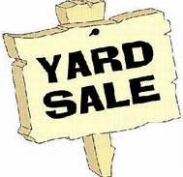Yard Sale March 29th
7 am until 12 noon
Reserve Your Spot Now

First Baptist Church of Carolina Beach
409 North Lake Park Blvd.

Call the church office at 910-458-5134 and reserve your spot for only $15.00
All monies raised will support the College age Young Adult’s Class at
First Baptist Church of Carolina Beach.

Their goal is to take a mission trip this summer!
It’s time to clean out your closets and make some extra money!!! Yes, you keep what
you sell and support a good cause at the same time! We have the best
spot on the island to set-up and sell your things!
We will set-up on the Gazebo side of the church facing Lake Park Blvd!

